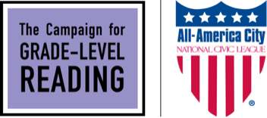
2022 All-America City Award
Letter of Intent to Apply Template
This is a sample for your use, but not the required language. Please email this letter by January 10, 2022 to aac@ncl.org to receive a $100 discount on your AAC application fee (full application fee is $250). Please note that a letter of intent is not required to submit an application.
All-America City Awards
National Civic League
190 East 9th Ave
#200
Denver, CO 80203

Dear National Civic League staff:

I am writing on behalf of (the town, city, county, tribe, region), in the state of (name) to inform you of our intent to apply for the 2022 All-America City Awards.

We believe we are an excellent candidate for the All-America City Award because (please provide a few sentences about how your community has improved the prospects for early school success and equitable learning recovery for the children whose families are served by the nation’s public housing agencies and affordable housing organizations.

Our community contact person will be:
Name
Title or role it the community
Contact (email and phone)

We understand the application deadline is March 1, 2022.

Sincerely,

Name, title (if desired), email and phone contact

