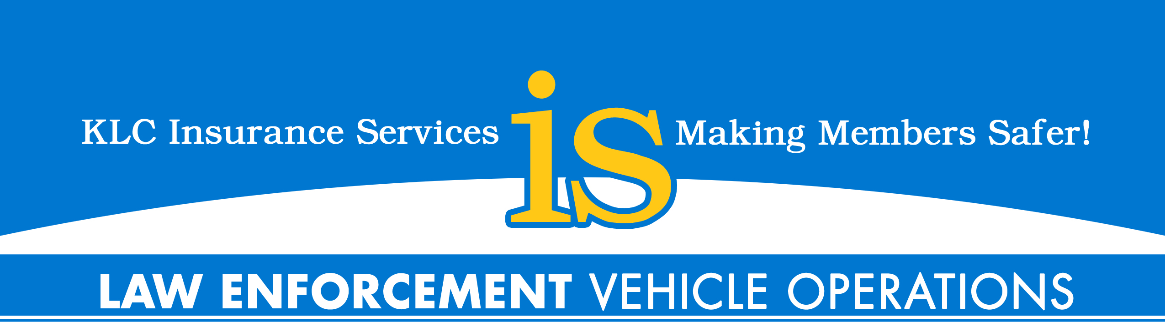

Goal: This tip sheet is provided to KLCIS Law Enforcement Members to restore awareness associated with the safe operation of emergency vehicles so as better protecting police officers and citizens throughout the Commonwealth of KY. This is not an all-inclusive vehicle operations training program but appropriate for “roll call” remedial, or individual officer training.

- Pre-shift inspection: Tire pressure & tread wear, fluids, lights, emergency equipment, clean windows, and properly set mirrors & seat. Be aware of blind spots (yours and vehicles around you). Weather changes impact many of these items.
- Proper mindset & attitude. Be aware of everything around you and drive defensively. Be aware of upcoming intersections.
- Distracted driving. Don’t text or operate mobile data terminals and limit cell phone calls to emergencies calls when vehicle is in operation. Never drive code 3 while on cell phone. Cell phone usage while driving is four times more likely to result in a vehicle collision. Texting can increase your perception-response time by as much as 3 seconds.
- Back in to parking spaces when tactically acceptable. Backing in upon arrival and especially in parking lots greatly reduces vehicle collisions. Park in a position to avoid backing up when leaving. Tactics 1st.
- Hand positioning. 8 & 4 or 9 & 3. Better control of vehicle and reduces airbag injuries. Remember to keep thumbs on the outside of steering wheel to avoid airbag injuries.
- Seatbelt. Always wear your seatbelt. Practice exiting the vehicle quickly from a seat belted in position.
- Beware of driver fatigue or prescribed prescription drugs as both can impact a drivers ability to safely operate a vehicle. Read label on your prescriptions and consult with pharmacist when taking medication. Notify supervisor.

- On nonemergency runs operate vehicle within posted speed limits. Operate vehicle under control. Avoid improper lane changes, improper passing and always utilize turn indicators to signal movement of vehicle.
- On emergency runs operate vehicle under control. Drive with “due regard” and within KRS.
- Avoid following too closely. Drive tactically sound and don’t put yourself in an unsafe position! Give yourself time and distance to maneuver.
- Weather. Rain, sleet, ice, snow and fog all impact safe driving.
- Night time driving reduces visibility; slow down. Don’t overdrive your headlights.
- Utilize back-up sensor with audible warning for driver/cameras. New vehicle purchases should include a back-up sensor with audible warning for driver/cameras.
- Position vehicle tactically and out of travel portion of the roadway on traffic stops. Utilize all emergency and hazard lights. Wear your body armor as it has additionally shown to protect officers in traffic accidents. Wear your retro reflective vest for increased visibility of approaching motorist.
- Secure items within the vehicle. Unsecured items can become a projectile and injure occupants.
- Know your department’s pursuit policy. At a minimum review on an annual basis. Be aware of pursuit liabilities and current case law.
- Department should conduct annual vehicle operation training. This can include vehicle operations, policy review, and/or education materials such as videos.

For additional information please contact KLCIS Law Enforcement Specialist:

Troy Pitcock Cell: 502-376-4027 tpitcock@klc.org
Mark Filburn Cell: 859-327-9750 mfilburn@klc.org

