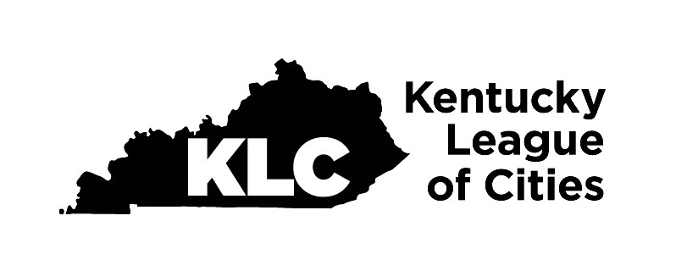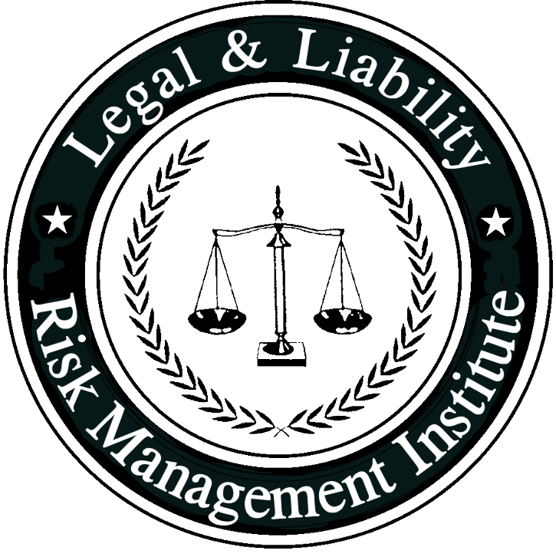
Policy #  Audits and Inspections | Related Policies:
This policy is for internal use only and does not enlarge an employee’s civil liability in any way. The policy should not be construed as creating a higher duty of care, in an evidentiary sense, with respect to third-party civil claims against employees. A violation of this policy, if proven, can only form the basis of a complaint by this department for non-judicial administrative action in accordance with the laws governing employee discipline.
Applicable State Statutes:
KACP Accreditation Standard: 12.6, 14.4, 21.2, 27.3,
Date Implemented: |  | Review Date: June 7, 2023

- PURPOSE: Some police operations and tasks have a high-risk, high-liability potential. These police operations must be undertaken in a consistent, methodical manner in an attempt to undertake the necessary police operation/task, yet reduce the liability potential. This liability potential can be reduced when the agency can document that the procedures in place were consistently followed. A police department must conduct formalized, regular audits and inspections of these high-risk, high-liability operations and tasks.

- POLICY: This agency will conduct audits and inspections of designated police operations and tasks on both a scheduled and unannounced frequency.

- PROCEDURE: The following operations and tasks shall be audited and inspected by a person/unit designated by the chief of police. This person/unit shall be directly responsible to the chief of police. The person(s) conducting the audit/inspection shall use the formal checklist to ensure that all relevant areas of concentration are addressed in the audit/inspection. The ultimate purpose of these inspections is to ensure that the operation/task is being conducted consistent with agency policy/procedure and the law. Scheduled inspections shall enlist and involve the personnel of the unit/function being inspected unless there is an indication that this would inhibit the process of the audit/inspection. Unannounced audits/inspections shall be conducted at the direction of the chief of police. The following operations/tasks shall be audited/inspected on the following schedule:

  - Access to the criminal information system - Quarterly
  - Citizen complaint investigations - Annually
  - Use of force/control of resistive persons reports - Monthly/Annual report
  - Pursuit reports - Quarterly/Annual Report
  - Property/evidence (narcotics, money, guns) - Quarterly
  - SWAT equipment and training - Annually
  - Crowd control contingency plans and equipment - Annually
  - Less lethal weaponry - Monthly
  - Video camera supervisory reviews - Quarterly
  - Mandated training - Quarterly/Annual Report

- The process of the inspection/audit shall respect the dignity of all agency personnel and be conducted in a professional manner.

- WRITTEN REPORT:
  - Each audit/inspection shall be reduced in writing.
    - Specific examples of positive and negative issues, if observed, shall be identified.
    - This report shall be forwarded directly to the chief of police.

- FOLLOW-UP REQUIREMENTS:
  - Each audit/inspection report that identified a deficiency or area of concern shall result in a follow-up audit/inspection within one month of the discovery of the deficiency.

- MAINTENANCE OF AUDIT/INSPECTION REPORTS:
  - All reports of audits/inspections shall be maintained in a secure location for a minimum of five years or longer where required by state law.

