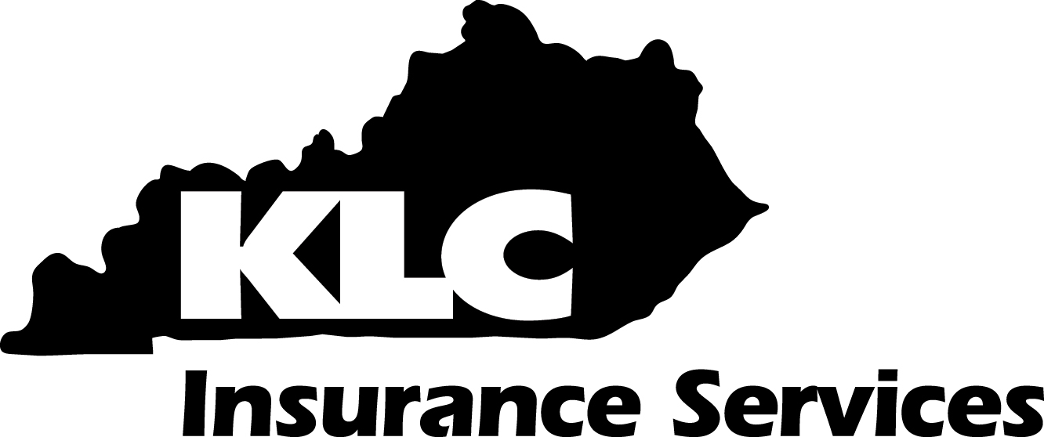
Policy #  Use of Intranasal Naloxone | Related Policies:
This policy is for internal use only and does not enlarge an employee’s civil liability in any way. The policy should not be construed as creating a higher duty of care, in an evidentiary sense, with respect to third party civil claims against employees. A violation of this policy, if proven, can only form the basis of a complaint by this department for non-judicial administrative action in accordance with the laws governing employee discipline.
Applicable Kentucky Statutes:
KACP Accreditation Standard:
Date Implemented: |  | Review Date:

- Purpose: The purpose of this policy is to provide sworn officers with guidelines, instructions and procedures to utilize naloxone in order to reduce fatal opioid overdose.
- Policy: It is the policy of this Agency to provide assistance to any persons(s) who may be suffering from an opioid overdose. Officers trained in accordance with this policy shall make every reasonable effort to use naloxone to revive victims of any apparent drug overdose.
- Discussion: This policy is intended to address one of the responsibilities of all sworn officers, which is to protect the safety and welfare of all persons and the community. In this regard, officers need to recognize the symptoms that victims who are suffering from an opioid overdose display so as to ensure that fast and effective medical assistance is dispensed. Drug overdoses are a major cause of preventable death in the United States. Increasingly, this includes prescription opioids, along with illegal opiate drugs like heroin. (Opioids are synthetic substances that mimic the narcotic effect of opium, from which heroin is derived.)
- Definitions:
  - Drug Intoxication: Impaired mental or physical functioning resulting from the use of physiological and/or psychoactive substances; i.e. euphoria, dysphoria, apathy, sedation, attention impairment.
  - EMT: Emergency Medical Technician, medical care rendered by EMT practitioners, which ensure the provisions of emergency medical assistance in the field for those persons suffering from an illness or injury.
  - MAD: The intranasal Mucosal Atomization Device which is used to deliver a mist of atomized medication that is absorbed directly into a person’s blood stream and directly into the brain and cerebrospinal fluid via the nose to brain pathway. This method of medication administration achieves medication levels comparable to injections.
  - Naloxone: An opioid receptor antagonist and antidote for opioid overdose which is produced in intramuscular, intranasal or intravenous forms.
  - Narcan: 2mg/2ml prefilled naloxone syringe that is compatible with the intranasal MAD.
  - Opioid: An opioid is a psychoactive chemical pain medication such as, fentanyl, morphine, buprenorphine, codeine, hydrocodone, methadone, and oxycodone.
  - Heroin: A white, crystalline narcotic powder that is a highly addictive drug derived from morphine.
  - Opioid Overdose: An acute condition due to excessive use of narcotics, indicated by symptoms including, but not limited to, extreme physical illness, decreased level of consciousness, respiratory depression, coma, or death, resulting from the consumption or use of an opioid or another substance with which an opioid was combined, or that a layperson would reasonably believe to be caused by an opioid-related drug overdose that requires medical assistance.
  - Universal Precautions: An approach to infection control whereby all human blood and human body fluids are treated as if they were known to be infectious for HIV, HBV, and other blood-borne pathogens. The use of latex gloves for purposes of this policy is a highly recommended best practice.
  - Signs of Overdose: A person who has overdosed may:
    - be breathing very slow or not breathing
    - have blue or purplish lips or fingernails
    - be limp
    - pinpoint pupils
    - be vomiting or gurgling
    - not wake up or respond if you try to rouse him
- Issuance of Naloxone:
  - Naloxone for intranasal use will be issued to all sworn officers. Each kit will include:
    - Instructions for administering intranasal naloxone.
    - One (1) single-use Luer-Lock prefilled syringe system.
    - One (1) MAD.
- Procedure:
  - Officers shall receive Agency approved and authorized training on responding to persons suffering from an apparent opioid overdose and the use of naloxone prior to being issued and intranasal naloxone kit and/or being authorized to administer naloxone.
  - Officers of this Agency shall receive approved and authorized refresher training on responding to persons suffering from an apparent opioid overdose and the use of naloxone every two (2) years.
  - Whenever an officer encounters a person who appears to be the victim of a drug overdose, the officer shall:
    - Maintain universal precautions throughout the event.
    - Contact and advise the dispatcher of a possible overdose and request EMS response.
    - Keep the dispatcher apprised of the condition of the overdose victim.
    - Perform an assessment of the victim checking for unresponsive and decreased vital signs.
    - Check for Medic Alert tags or the like, which may indicate a pre-existing medical condition, around the wrist or neck of the victim.
    - Ask witnesses, family or friends of the victim what type of drug the victim ingested.
    - Observe your surroundings for any evidence of drugs that may indicate what the victim ingested such as; prescription drug bottles, heroin packages, needles and syringes.
    - Prior to the administration of naloxone, officers shall ensure that the victim is in a safe location and shall remove any sharp or heavy objects from the victim’s reach, as the sudden onset of immediate opioid withdrawal may result in physical symptoms such as agitation, rapid heart rate, nausea, seizures and difficulty breathing.
    - Administer naloxone using the approved MAD.
    - Seize all illegal and/or non-prescribed narcotics found on the victim or around the area of the overdose and process in accordance with Agency policy and inform medical personnel of the drugs recovered.
    - Once used, the intranasal naloxone device is considered bio-hazardous material and shall be turned over to EMS or hospital personnel for proper disposal.
  - Administration of Naloxone:
Step #1 Step #2 Step #3 MAD Step 4
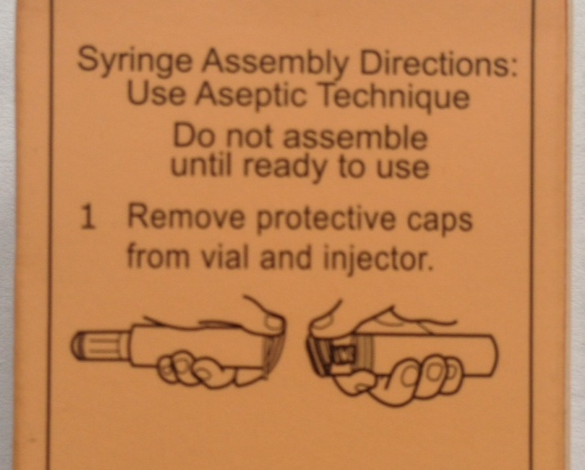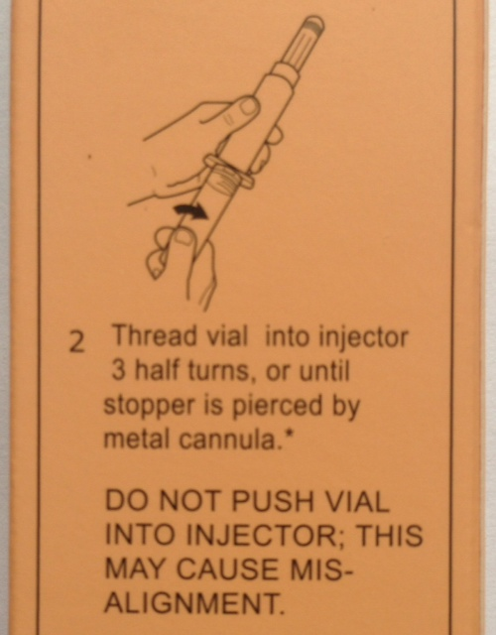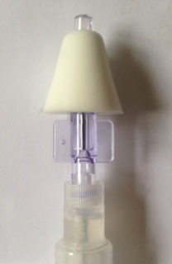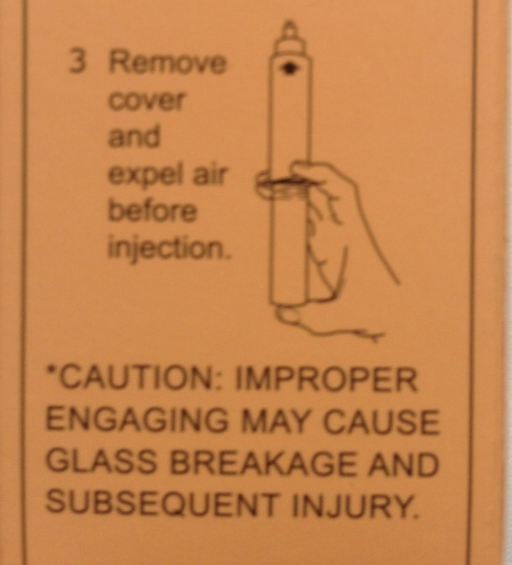

    - Step #1- Remove protective caps from vial and injector.
    - Step #2-Thread the vial into the injector 3 half turns, or until the stopper is pierced by the metal cannula.
    - Step #3-Remove the MAD and place in the tip of the injector.
    - Step #4-Expel air before injection.
    - Step #5-Place the MAD in one nostril of the victim and pinch the other closed. Administer 1 ml into the nostril. Remove the MAD and place it into the other nostril. Pinch the other nostril closed and administer the remaining 1 ml of naloxone.
    - Maintain constant observation of the victim and update dispatch and medical personnel on the condition of the victim.
    - You should notice improvement in breathing in 2- 3 minutes.

  - Reporting: After utilization of naloxone, officers shall:
    - Prepare an incident report to include a description of the individual’s condition, symptoms and behaviors; the fact that naloxone was deployed; EMS response; the hospital to which the victim was transported; any narcotics seized; and the outcome of the agency and EMS response.
    - The on scene supervisor or the on-duty supervisor will review and approve the report.
  - Storage and Replacement:
- Inspection of the intranasal naloxone kit shall be the responsibility of the officer to whom it is issued and shall be conducted by the officer prior to each shift along with the rest of the Agency issued equipment.
    - Check the expiration date found on the box or vial.
    - Check the condition of the MAD. When unopened it is considered sterile for 4-5 years.
- Naloxone will be stored in accordance with the manufacturer’s instructions, avoiding extreme cold, heat and direct sunlight.
- Missing, damaged and expired kits will be reported to the officer’s immediate supervisor as soon as the discrepancy is noted.
- Replacement kits will be provided to officers.

