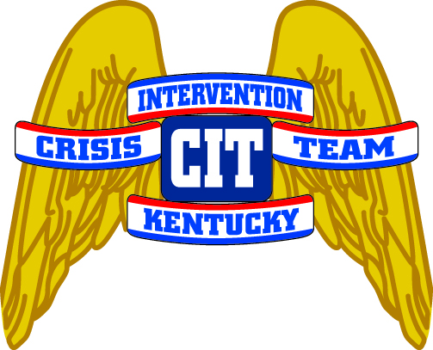 CIT Classes for 2019
(KLEC Certified – 40 Hrs.*)

DATE | LOCATION* | **RECOMMENDED FOR OFFICERS IN THIS MENTAL HEALTH REGION:
January 21-25, 2019 | Owensboro  Cigar Factory Complex, 1100 Walnut Street | River Valley Behavioral Health
March 11-15, 2019 | Somerset  Hal Rogers Fire Trng Ctr  180 Oak Leaf Lane | Adanta
May 20-24, 2019 | Northern KY  Boone County Sheriffs Office  3000 Conrad Lane | NorthKey
June 10-14, 2019 | Lexington Area  TBD | Bluegrass.org
July 8-12, 2019 | Paducah  Four Rivers, 425 Broadway  2nd Floor Classroom | Four Rivers Behavioral Health
August 26-30, 2019 | Bowling Green  Bowling Green PD  911 Kentucky St. | Lifeskills
September 16-20, 2019 | Lexington Area  TBD | Bluegrass.org
October 14-18, 2019 | Northern KY  Boone County Sheriffs Office  3000 Conrad Lane | NorthKey
November 4-8, 2019 | Ashland  Ashland Police Dept.(??) | Pathways
November 18-22, 2019 | Elizabethtown | Communicare

Locations are subject to change.

All Classes are KLEC certified for 40 hours.

**NOTE: Officers are encouraged to attend the class in their mental health region to receive the full benefits of the course.

Contact the Department of Criminal Justice Training to register for classes. Questions can be referred to Lt. Denise Spratt (ret.) #502-643-7539 or denise.spratt@kentuckycit.com .

Submitted by Denise Spratt
Crisis Solutions, LLC Corrected 10/12/18

